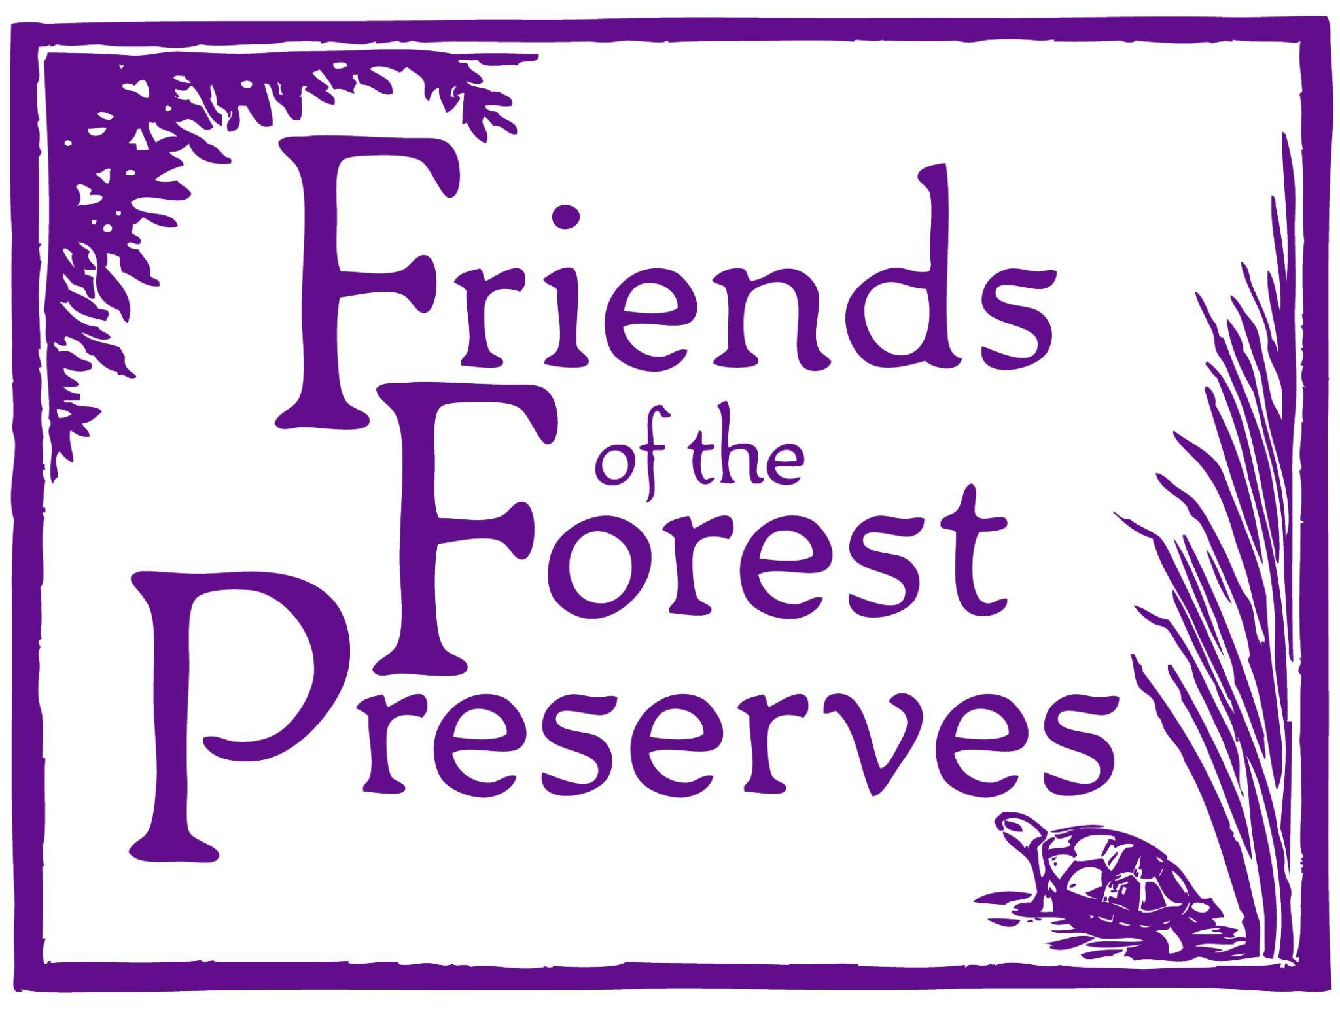
Chicago Conservation Leadership Corps

The Chicago Conservation Leadership Corps program (CCLC) is a five-week conservation service-learning experience. Selected individuals will participate on crews that will consist of 10 high school students, one apprentice leader, and two adult crew leaders.

As a team, the crew will perform ecological restoration and trail maintenance projects in the Forest Preserves of Cook County. Each Wednesday, students will participate in field days learning about the local ecology and the environment at various sites throughout the region. See below for FAQs!

Q: What are the age requirements to participate in the program?

A: Students must be 14-19 years old by program start and enrolled in high school or be a 2023 high school graduate.

Q: What is the COVID-19 requirement?

A: During the CCLC program participants are asked to wear masks when in closed spaces and in close proximity to each other.

Q: How do I apply?

A: Visit www.fotfp.org/jobs and apply online under the “Member Application” or download a printable version. The application is open and will close on April 21st, 2023.

Q: What is the time commitment and how does transportation work?

A: The program will run from July 5th, 2023 to August 9th, 2023. Students generally work Monday-Thursday from 8 AM to 3:30 PM, 28 hours/week and receive a wage of $13.50/hr. If you are being picked up by your crew leader you must be at the designated pick-up location by 7:15am to be onsite to start with the rest of the crew at 8am. Leaders will not be picking up or dropping off members at their houses, and it is your responsibility to communicated with your leader if you will be late. If a student misses more than 3 days of work they will be dismissed from the program and will forfeit the remaining pay. There are no exceptions for family vacations or summer school.

Local participants are encouraged to meet on site at one of the following summer locations to participate, but we the CCLC program does provide transportation to those who cannot meet at the nature center:
- River Trail Nature Center, 3120 Milwaukee Ave, Northbrook, IL 60062
- Little Red Schoolhouse Nature Center, 9800 Willow Springs Rd, Willow Springs, IL 60480
- Sand Ridge Nature Center, 15891 Paxton Ave, South Holland, IL 60473
- Trailside Museum 738 Thatcher Ave, River Forest, IL 60305

Q: What exactly do students do and where do they work?

A: Students will spend their first week learning job skills that will prepare them for the program and give them skills that they can use in the future. They then engage in rewarding and valuable physical work outdoors on conservation and restoration projects in the Forest Preserves of Cook County including trail work, invasive species removal and nature center projects. Throughout each week time will be devoted to learning about the local ecology and environment. Once a student is hired, they will usually be placed at the forest preserve work site that is closest to their home.

Q: How can I improve my chances of getting into the program?

A: We highly encourage you to spend time thinking about and answering the essay section of your application. If you are able to, consider visiting or volunteering (if safe to do so) at a local forest preserve or nature center to learn more about what setting you may be working in or what type of work you will be doing this summer. We receive many applications and are looking for students that are excited about working in the forest preserves and helping our environment.

APPLY BY: April 21st. Application can be found at: https://docs.google.com/forms/d/e/1FAIpQLSepnp3DamydTfuVjzChnI9_0q6H5ZH4S84V8gy4SQENjjI-_A/viewform?usp=sf_link or visit Job Openings - Friends of the Forest Preserves (fotfp.org)

Q: Who do I call with additional questions?

A: For more information, please contact:
Hannah Miller
hannah@fotfp.org
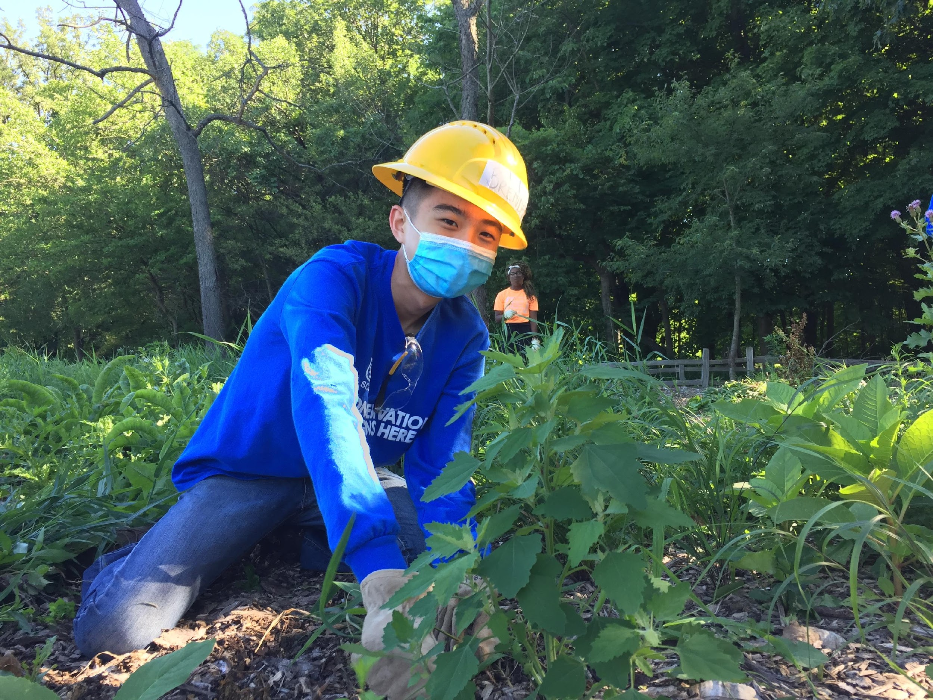
Program Manager
Friends of the Forest Preserves
312-356-9990 ext.308

Samuel Vergara
svergara@thesca.org
Chicago Program Manager
Student Conservation Association
312-239-1661 ext.6009

